DebateHub: A platform for the Nuanced Discussion

DebateHub is a web application where users engage in nuanced discussions on various topics. Users can post debate questions with multiple viewpoints, vote on them, and interact with other users in a dynamic, community driven environment.

TRAINER: BY:
Shilpa Pingali, Infosys Aman Kumar Gupta

1. Problem Statement
Modern social platforms often lack the depth and structure for meaningful discussions. DebateHub solves this by creating a platform for structured debates and discussions where users can post questions (debate topics) with 2 to 7 viewpoints (options). These debates are community-driven, allowing users to vote on options, express preferences, and engage meaningfully.
Key Features:
- Create debates with multiple viewpoints.
- Vote distribution visualized graphically.
- Search, filter, and sort debates.
- Social features like liking/disliking debates.
- Admin moderation for debates and user activity.
Outcome: Users experience a community-oriented space for nuanced debates, and admins ensure the platform remains well-regulated and engaging.

2. Tech Stack
Frontend: ReactJS (with Vite for enhanced development performance).
Backend: Node.js with Express.js.
Database: MongoDB for scalable and efficient data storage.

3. External Libraries
- bcrypt (^5.1.1): For secure password hashing.
- cors (^2.8.5): To handle Cross-Origin Resource Sharing, enabling the frontend to interact with the backend.
- dotenv (^16.4.5): Manages environment variables securely.
- ejs (^3.1.10): Template engine for rendering HTML with embedded JavaScript (optional for server-side rendering).
- express (^4.21.2): Web framework for building RESTful APIs.
- express-validator (^7.2.0): Middleware for input validation and sanitization.
- jsonwebtoken (^9.0.2): For generating and verifying secure JSON Web Tokens (JWT).
- mongoose (^8.8.1): ODM library for interacting with MongoDB.
- nodemailer (^6.9.16): For sending emails, such as account confirmations or notifications.
- nodemon (^3.1.7): Development tool for auto-restarting the server on code changes.

MODULES
USER MODULE:
- Create Debates: Users can create new debates by specifying a question and 2-7 viewpoints (options).
- Vote on Debates: Each user can cast up to 10 votes across debate options, with graphical displays of vote distributions.
- Search Debates: Users can search for existing debates and view questions, options, and current voting stats.
- Like/Dislike Debates: Users can like or dislike a debate question to express their opinion.

ADMIN MODULE:
- Debate Moderation:
- Admins have the authority to close debates, which halts any further participation or modifications.
- Admins can edit or remove debate options or even delete entire debates when necessary.
- User Management: Admins can control user accounts by activating or suspending users, allowing them to manage roles and access.
- Moderation and Oversight: Admins are empowered to filter, search, and review user profiles to ensure proper moderation and offer support when needed.
- Analytics & Statistics: Admins can access detailed analytics on debates, voting patterns, user behavior, and social engagement, helping to monitor and evaluate platform activity.

OUTPUT SCREENSHOTS

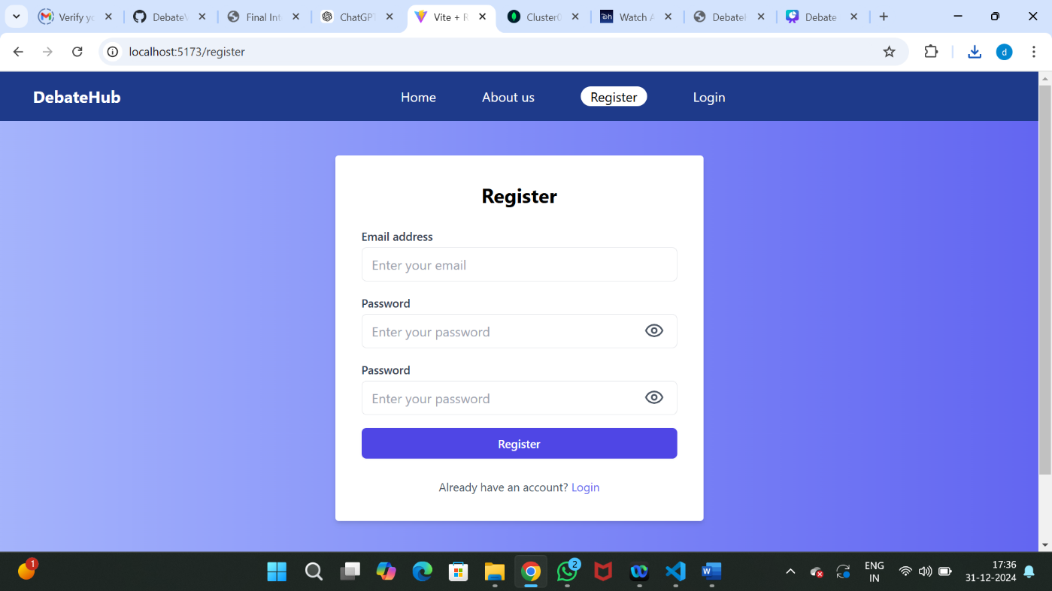
Register

Login

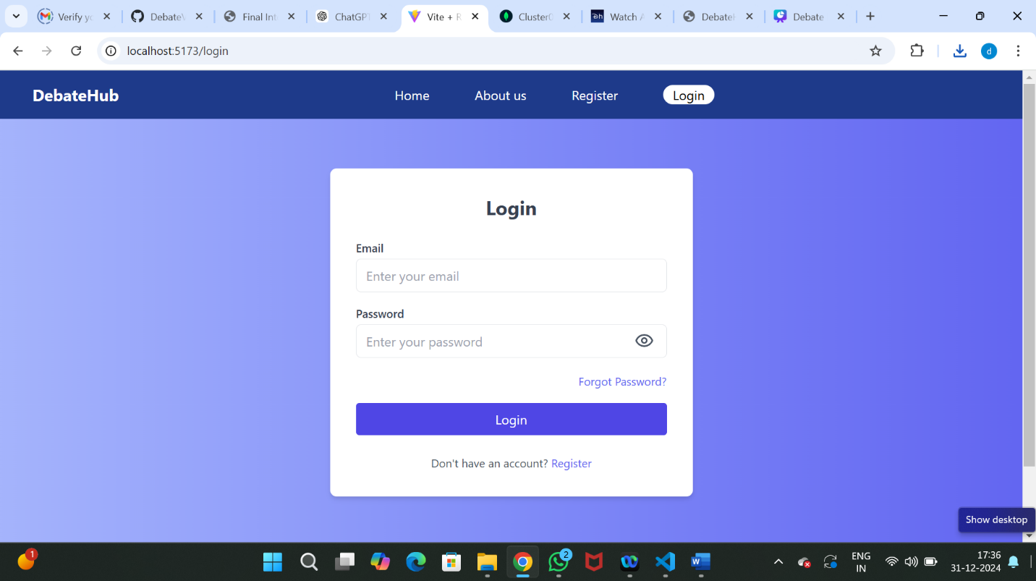

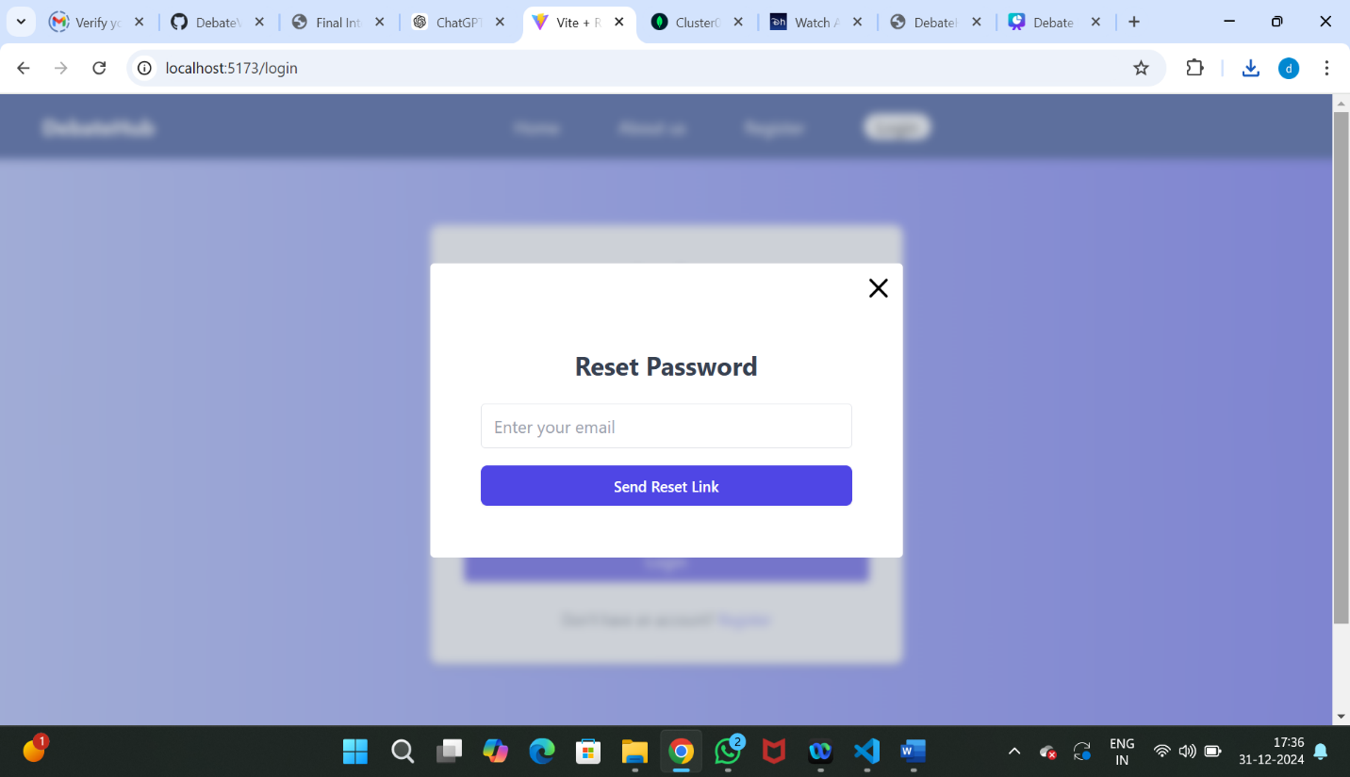
Reset password

User Dashboard
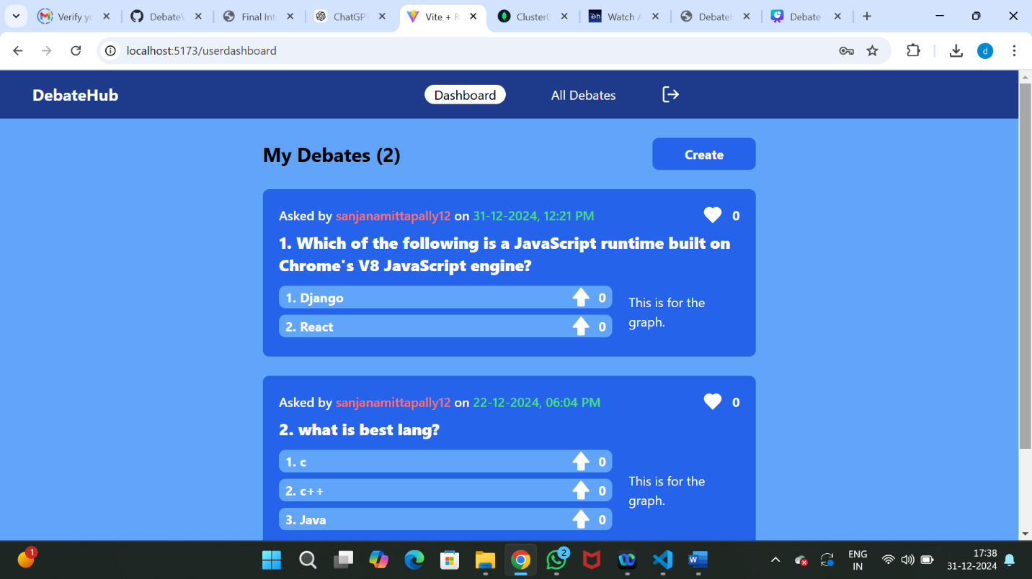

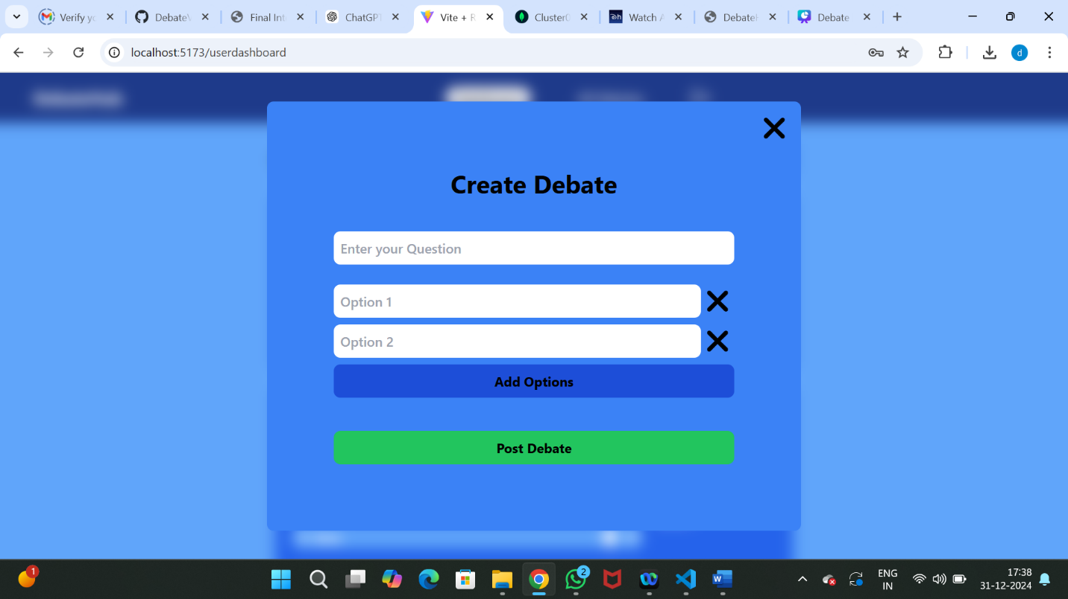
Create Debate

Search and Sort debates
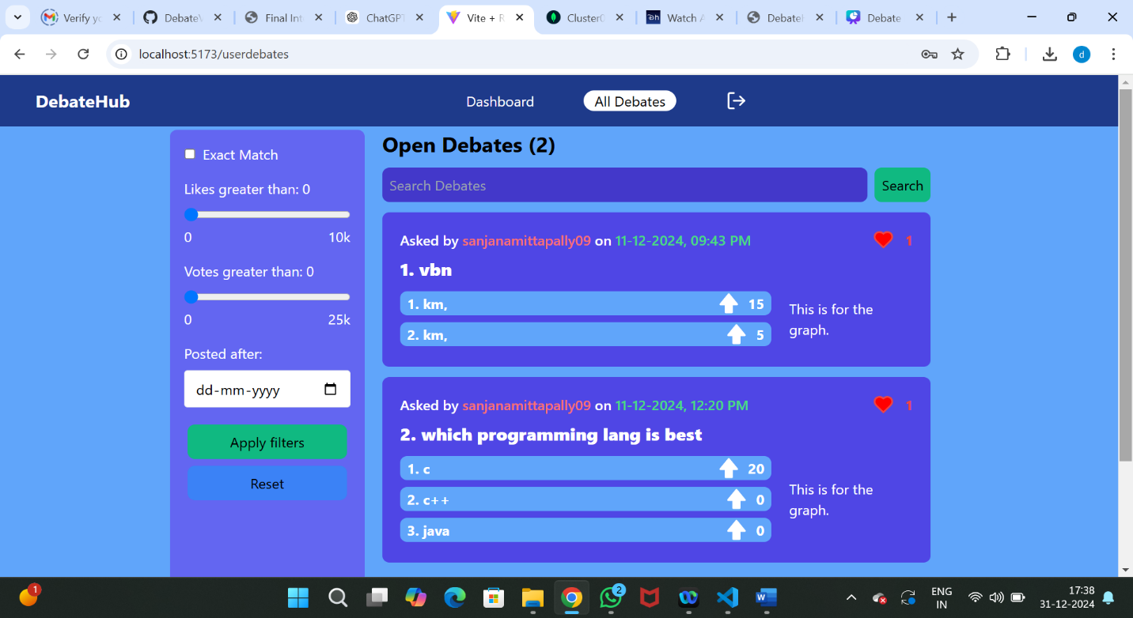

Admin Dashboard
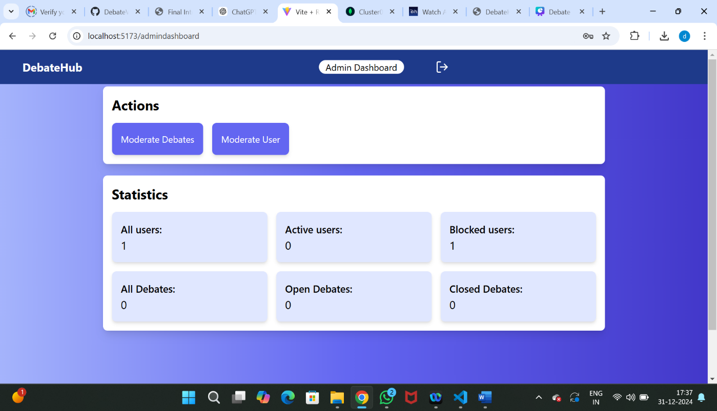

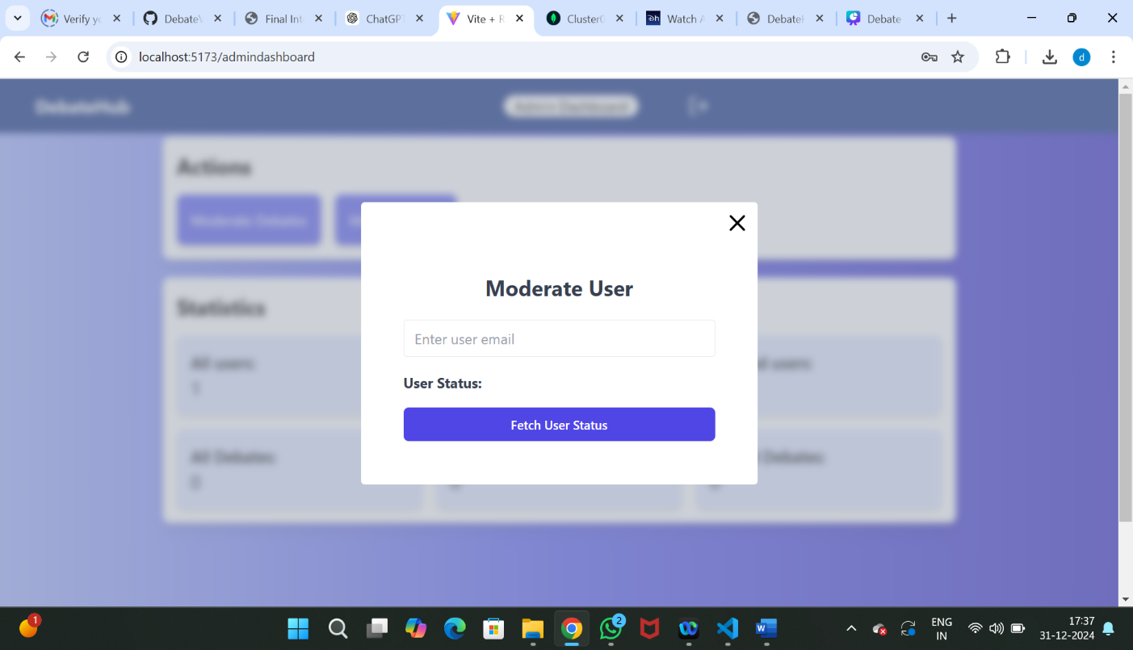
Moderate User

Manage Debate
